**P6 – Explain the different types of memory that can be attached to a processor**

**Introduction**

In this assignment, I will explain the different types of memory that is used when it is attached to a processor. They are many types, and I will be mentioning the following:

* Memory
* I/O Maps
* Direct Memory Access (DMA)
* EEPROM
* Cache
* RAM
* ROM
* Dynamic RAM

**Memory**

In computing, memory refers to any device that allows the user to store any data. Data could be anything, from images to documents. A physical device that allows data to be stored is computer, laptop, any console device e.g. PS4, PS3, and many more. They are a lot of devices that store data and all of this process is called memory. They are separate storages for data to be stored; it can be internal and external. Internal storages are RAM, ROM and many other that is inserted within a computer. External storage devices are USB, and many other physical devices that you insert to the computer to load up all the data.



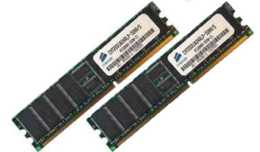**RAM**

RAM is known as random access memory is used to store data. This is inserted on the motherboard, which it is located there. When the computer is switched on, the files that are stored on the RAM automatically be operating as long as the computer is running. All the documents that you create is stored on the RAM.

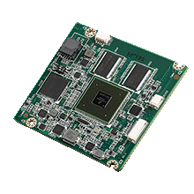**ROM**

ROM is known as read only memory. This is where data that is stored on this memory, but this cannot be changed. This is much different to RAM. ROM is where data is stored permanently on to this chip. As well as storing data, this gives out instructions.

**Dynamic RAM**

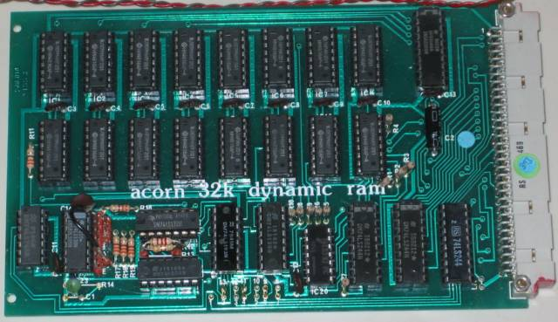This is also abbreviated as DRAM. This is use in most computers today. They are a few items a dynamic RAM. For each bit, they need a separate capacitor and transistor. DRAM stores data separately with a separate capacitor and transistor. A transistor is used to switch electronic signals within a circuit. The capacitor only stores charged (0) and discharged (1). Each charge gets taken away. This makes the process slow. This is used highly, but it had a low cost. This differs to the normal ‘RAM’, as this RAM needs to be refreshed all the time, otherwise it will lose its content.

**I/O maps**

An ‘I/O’ stands for Input/Output. I/O maps is a process between a processor and a peripheral. An I/O mapped is assigned to one or more of the processor’s I/O maps and they transfer information between the processor and peripheral using the input and output instructions. This means, they send it when a user sends an input. E.g. clicks the program to close, the expectation is to close the program. They do this by using the I/O maps and communicating between the processor and the peripheral.

**Direct Memory Access (DMA)**

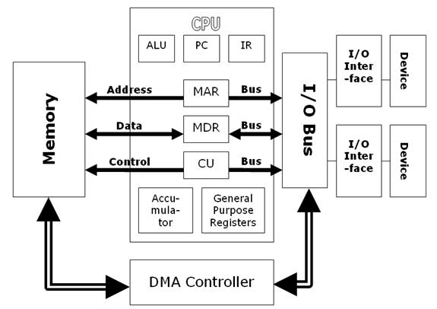DMA is a feature that allows the user to gain access to the main memory, and by being independently, the CPU cannot do it all itself. DMA allows the user to interpret, and send any attached device from the peripheral (output) to the memory on the computer’s motherboard. These files can be large, and using DMA, it is beneficial in this sense. As you can see on the picture (left), it shows how the DMA communicates. It communicates with the I/O bus. Each of the I/O bus is connected with a device. This enables communication between the two.

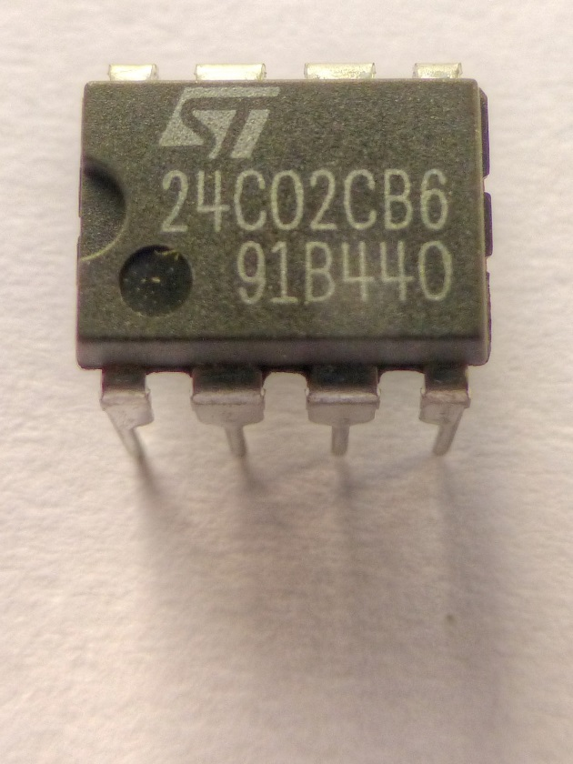**EEPROM**

[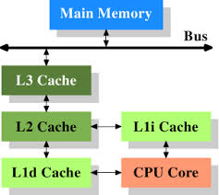](http://www.google.co.uk/url?sa=i&rct=j&q=&esrc=s&source=images&cd=&cad=rja&uact=8&ved=0CAcQjRw&url=http%3A%2F%2Flwn.net%2FArticles%2F252125%2F&ei=WMpgVNz3O7OKsQSX4oF4&bvm=bv.79189006,d.ZGU&psig=AFQjCNH5aVgkPLaBA5JB3gkkZvBzePOm8A&ust=1415715794084888)EEPROM stands for **e**lectrically **e**rasable **p**rogrammable **r**ead **o**nly **m**emory. This is a type of programme read only memory that enables content to be saved and retained even when the power is off. This content can be small amounts, large amounts cannot be saved on EEPROM. EEPROM can be similar to a flash memory. Flash memory is a type of EEPROM, but it erases and programmes in blocks whereas EEPROM does it in one byte.

**Cache**

A cache is a content that enables the request of the specific site to be located faster. It gets saved, but the computer does not know. This is to improve the input/output of the system. All these saved cache can be cleared, but when the I/O is requested, it will be slow.

**Reference**

* <http://www.cs.uwm.edu/classes/cs315/Bacon/Lecture/HTML/ch14s03.html>
* <http://en.wikipedia.org/wiki/Memory-mapped_I/O>
* <http://courses.cs.washington.edu/courses/cse378/07au/lectures/L20-Interrupt.pdf>
* <http://www.scs.stanford.edu/07au-cs140/notes/l11.pdf>
* <http://en.wikipedia.org/wiki/Cache_(computing)>
* <http://en.wikipedia.org/wiki/EEPROM>
* <http://en.wikipedia.org/wiki/Direct_memory_access>